**DAILY ONLINE ACTIVITIES SUMMARY**

|  |  |  |  |  |  |  |  |  |
| --- | --- | --- | --- | --- | --- | --- | --- | --- |
| **Date:** | **23/05/2020** | | | | | **Name:** | **Manish B Shriyan** | |
| **Sem & Sec** | **8th sem B sec** | | | | | **USN:** | **4AL16CS131** | |
| **Online Test Summary** | | | | | | | | |
| **Subject** | | **---** | | | | | | |
| **Max. Marks** | | **--** | | **Score** | | | **--** | |
| **Certification Course Summary** | | | | | | | | |
| **Course** | **Python 101 For Data Science** | | | | | | | |
| **Certificate Provider** | | | **Cognitive Class** | | **Duration** | | | **3 Hours** |
| **Coding Challenges** | | | | | | | | |
| **Problem Statement:**  **Python | Multiply all numbers in the list** | | | | | | | | |
| **Status: Solved** | | | | | | | | |
| **Uploaded the report in Github** | | | | | **Uploaded** | | | |
| **If yes Repository name** | | | | | **ManishShriyan** | | | |
| **Uploaded the report in slack** | | | | | **Yes** | | | |

Online Test Details:

No test conducted

Certification Course Details:

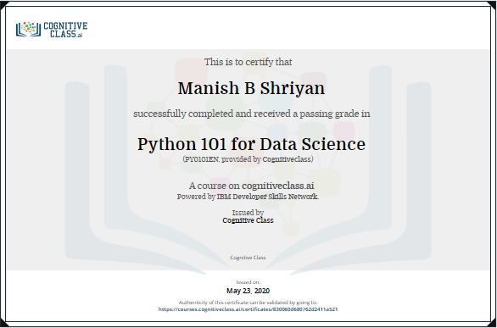

Coding Challenges Details:

def multiplyList(myList) :

    # Multiply elements one by one

    result = 1

    for x in myList:

         result = result * x

    return result

# Driver code

list1 = [1, 2, 3]

list2 = [3, 2, 4]

print(multiplyList(list1))

print(multiplyList(list2))